NAME: RAJA RAYYAN AMEER
REG. NO.: 23-CP-25
SECTION: ALPHA
SUBJECT: DATABASE MANAGEMENT SYSTEM
DEPARTMENT: COMPUTER ENGINEERING
TEACHER: SIR SHAHID
LAB 13
Challenge 1:
DELIMITER $$
CREATE PROCEDURE UpdateAppointmentStatus(
IN p_ApptID BIGINT,
IN p_NewStatus VARCHAR(20)
)
BEGIN
IF NOT EXISTS (SELECT 1 FROM Appointments WHERE ApptID = p_ApptID) THEN
SELECT CONCAT('Error: Appointment ', p_ApptID, ' does not exist') AS Message;
ELSE
UPDATE Appointments
SET Status = p_NewStatus
WHERE ApptID = p_ApptID;
SELECT CONCAT('Appointment ', p_ApptID, ' status updated to ', p_NewStatus) AS Message;
END IF;
END $$
DELIMITER;
INSERT INTO Appointments (ApptID, PatientID, DoctorID, ApptDate, Status)
VALUES (1000, 1, 10, '2025-02-20', 'Pending');
CALL UpdateAppointmentStatus(1000, 'Completed');
SELECT ApptID, PatientID, DoctorID, ApptDate, Status FROM Appointments WHERE ApptID =
1000;
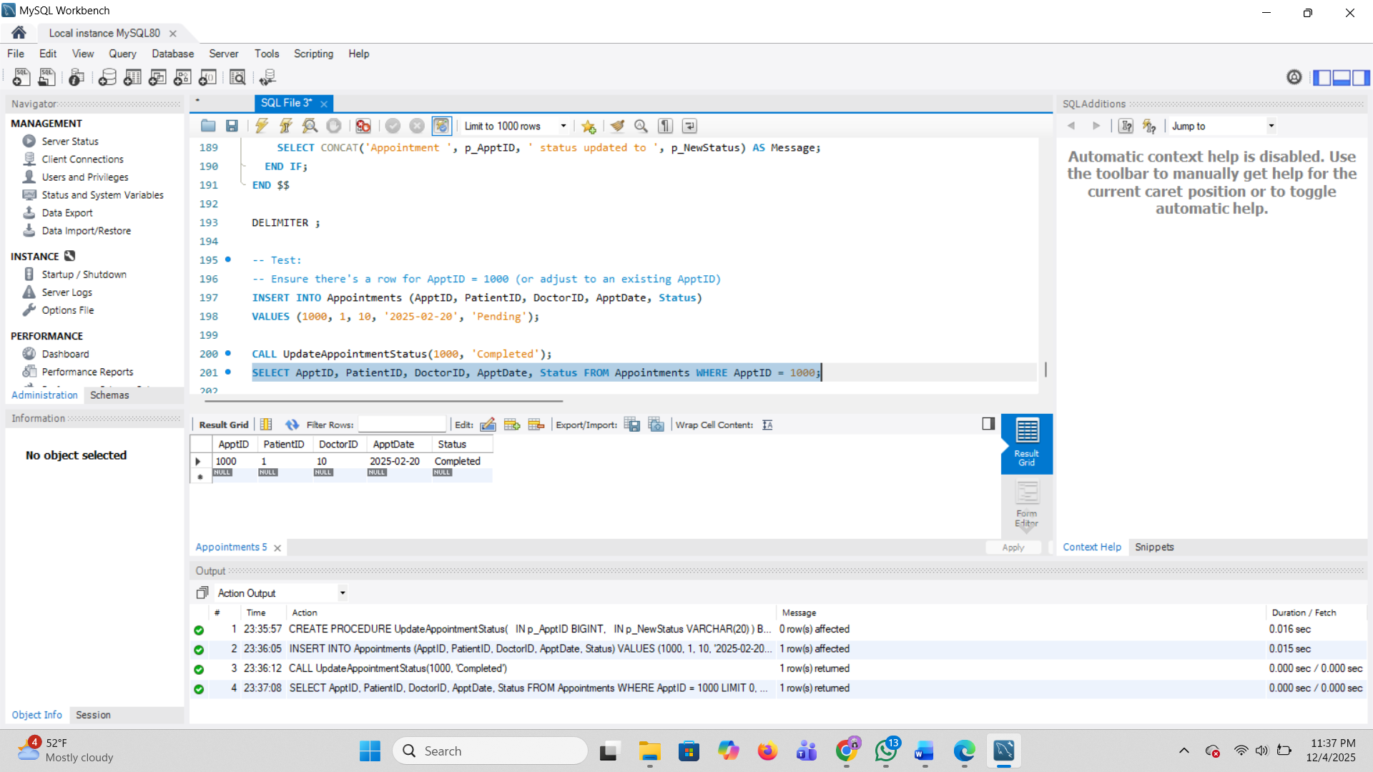
Challenge 2:
DELIMITER $$
CREATE FUNCTION DoctorMonthlyEarnings(
p_DoctorID INT,
p_Year INT,
p_Month INT
)
RETURNS DECIMAL(10,2)
DETERMINISTIC
BEGIN
DECLARE total DECIMAL(10,2);
SELECT COALESCE(SUM(t.Cost), 0)
INTO total
FROM Treatments t
JOIN Appointments a ON t.ApptID = a.ApptID
WHERE a.DoctorID = p_DoctorID
AND YEAR(a.ApptDate) = p_Year
AND MONTH(a.ApptDate) = p_Month;
RETURN total;
END $$
DELIMITER;
INSERT INTO Appointments (ApptID, PatientID, DoctorID, ApptDate, Status)
VALUES (2000, 2, 20, '2025-02-10', 'Completed');
INSERT INTO Treatments (TreatmentID, ApptID, Description, Cost)
VALUES (3001, 2000, 'Skin Allergy Treatment', 3500.00),
(3002, 2000, 'Follow-up Fee', 1500.00);
SELECT DoctorMonthlyEarnings(20, 2025, 2) AS Earnings_Feb_2025;
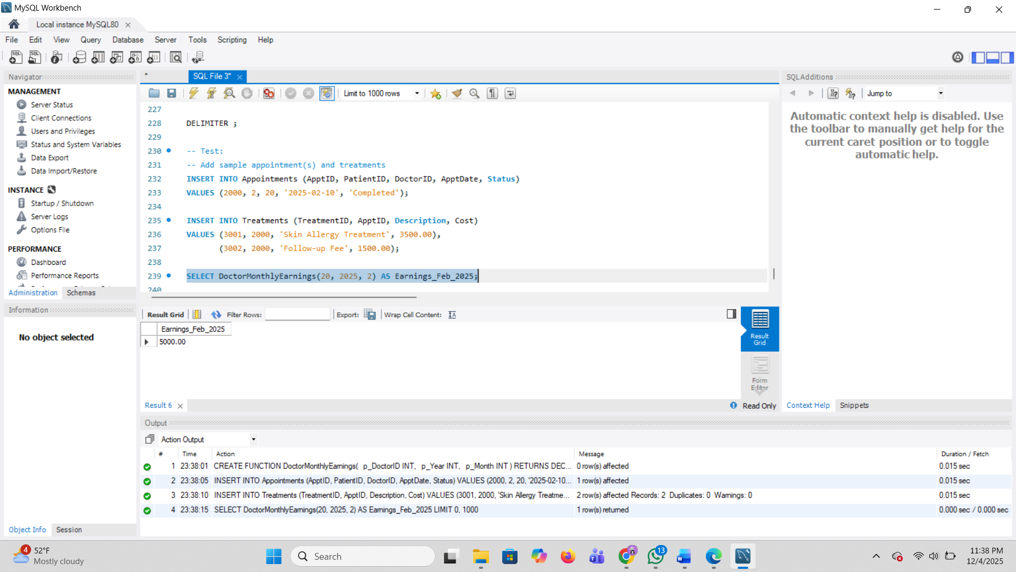
Challenge 3:
DELIMITER $$
CREATE PROCEDURE SafeAddTreatment(
IN p_ApptID BIGINT,
IN p_Description VARCHAR(200),
IN p_Cost DECIMAL(10,2)
)
BEGIN
IF NOT EXISTS (SELECT 1 FROM Appointments WHERE ApptID = p_ApptID) THEN
SELECT CONCAT('Error: Appointment ', p_ApptID, ' does not exist. Treatment NOT added.') AS Message;
ELSE
INSERT INTO Treatments (TreatmentID, ApptID, Description, Cost)
VALUES (UUID_SHORT(), p_ApptID, p_Description, p_Cost);
SELECT 'Treatment added successfully' AS Message;
END IF;
END $$
DELIMITER;
CALL SafeAddTreatment(2000, 'Extra Medication', 800.00);
CALL SafeAddTreatment(9999, 'Invalid Treatment', 100.00);
SELECT * FROM Treatments WHERE ApptID = 2000;
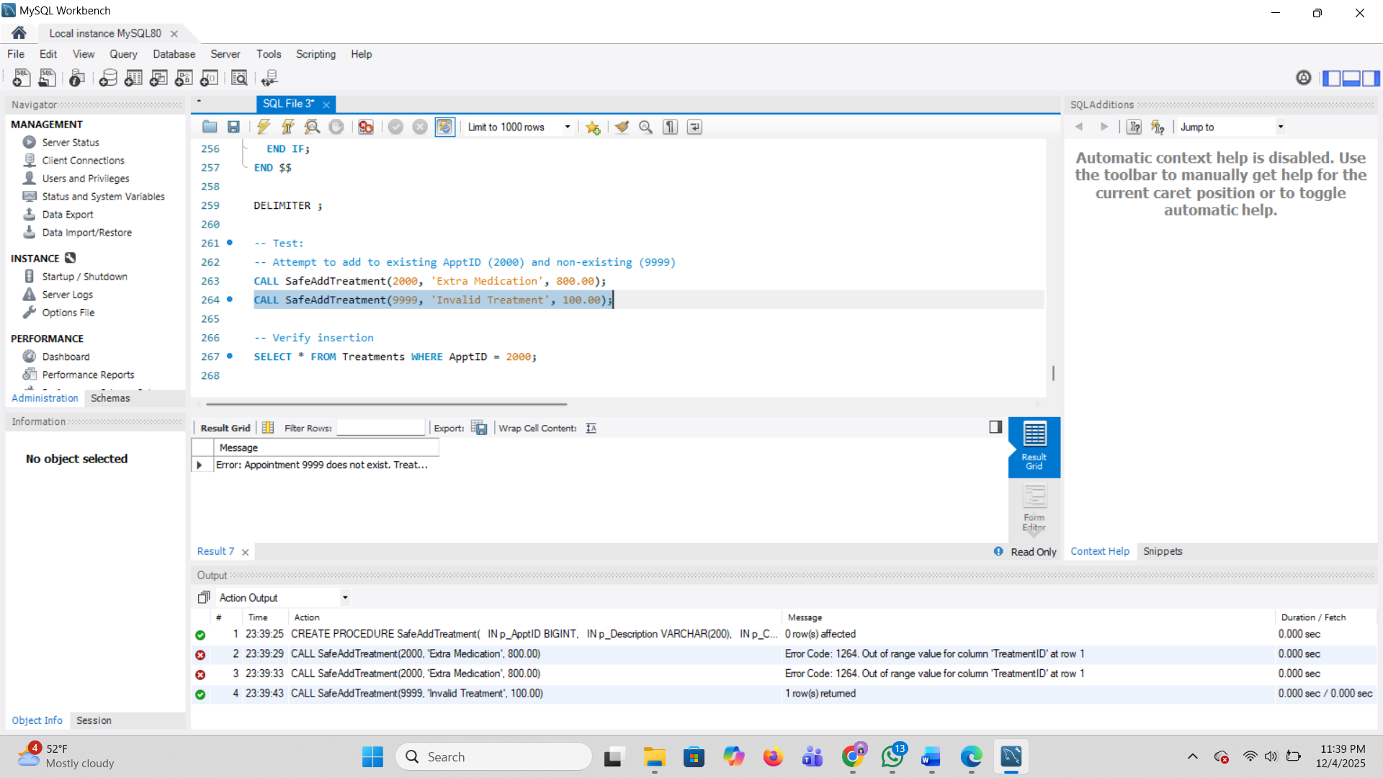
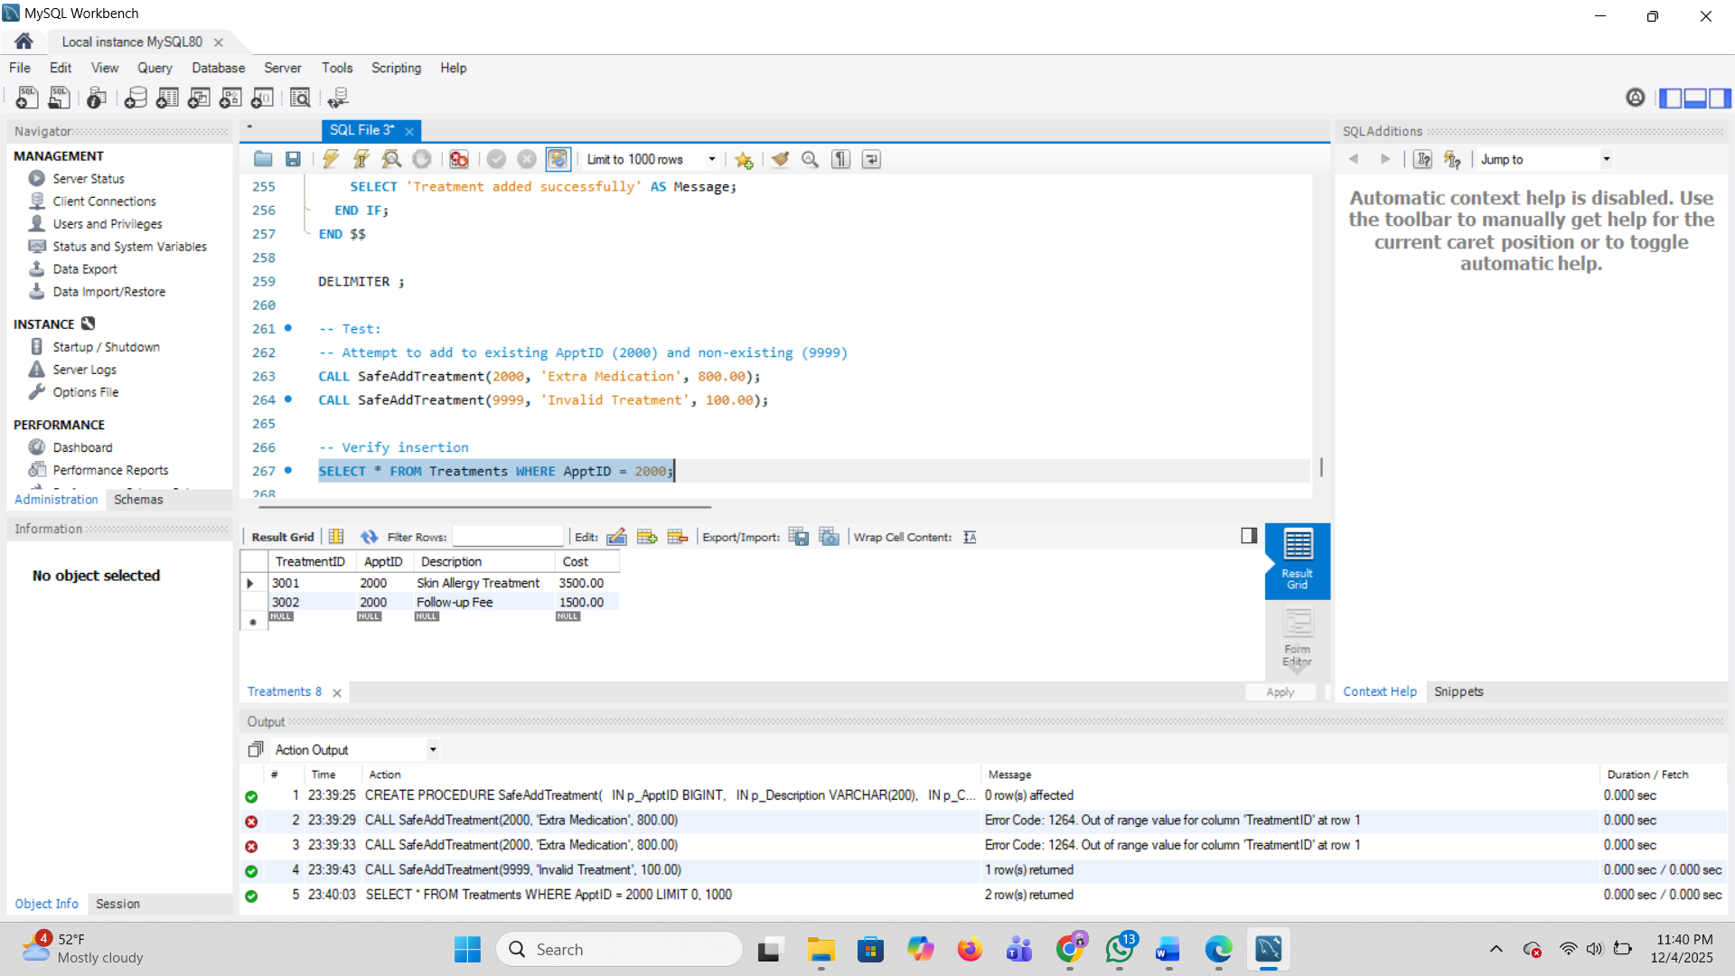
Challenge 4:
DELIMITER $$
CREATE FUNCTION StatusCodeToText(p_Code INT)
RETURNS VARCHAR(50)
DETERMINISTIC
BEGIN
RETURN CASE p_Code
WHEN 0 THEN 'Pending'
WHEN 1 THEN 'Completed'
WHEN 2 THEN 'Cancelled'
ELSE 'Unknown'
END;
END $$
DELIMITER;
SELECT StatusCodeToText(0) AS s0, StatusCodeToText(1) AS s1, StatusCodeToText(2) AS s2,
StatusCodeToText(9) AS s9;
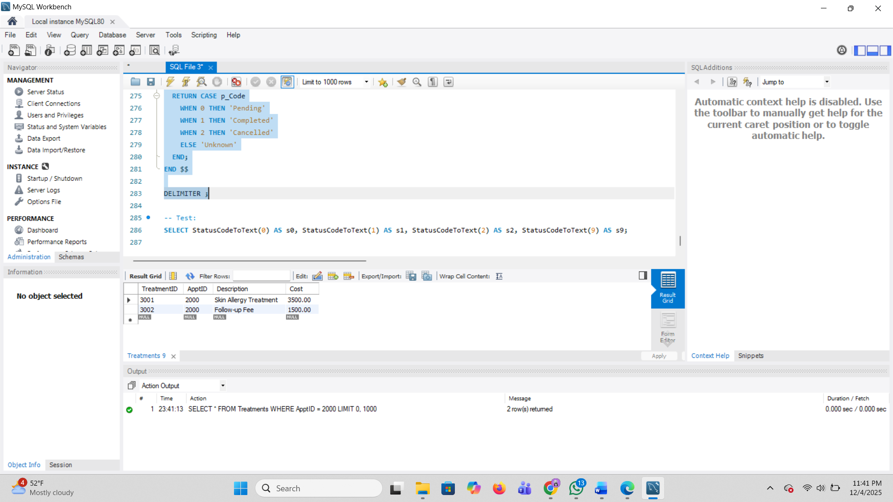
Challenge 5:
DELIMITER $$
CREATE PROCEDURE PatientFullSummary(
IN p_PatientID INT
)
BEGIN
DECLARE total_appts INT DEFAULT 0;
DECLARE completed_appts INT DEFAULT 0;
DECLARE total_billed DECIMAL(12,2) DEFAULT 0.00;
SELECT COUNT(*) INTO total_appts
FROM Appointments
WHERE PatientID = p_PatientID;
SELECT COUNT(*) INTO completed_appts
FROM Appointments
WHERE PatientID = p_PatientID AND Status = 'Completed';
SELECT COALESCE(SUM(b.TotalAmount), 0) INTO total_billed
FROM Billing b
JOIN Appointments a ON b.ApptID = a.ApptID
WHERE a.PatientID = p_PatientID;
SELECT p_PatientID AS PatientID,
total_appts AS TotalAppointments,
completed_appts AS CompletedAppointments,
total_billed AS TotalAmountBilled;
END $$
DELIMITER;
INSERT INTO Billing (BillID, ApptID, TotalAmount, PaymentStatus)
VALUES (UUID_SHORT(), 2000, 5000.00, 'Unpaid');
CALL PatientFullSummary(2);
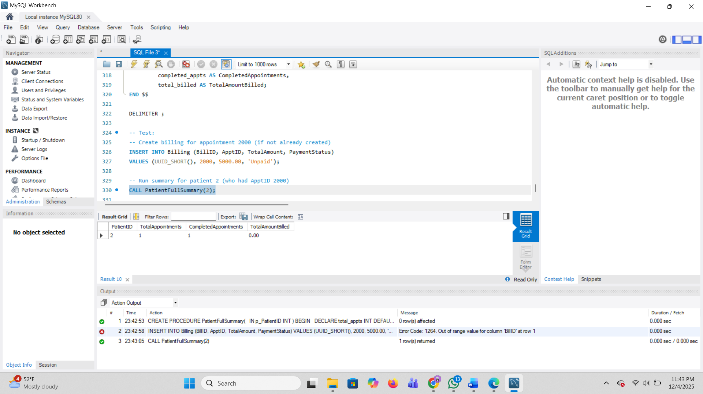
THE END

